SECURE DATA TRANSMISSION IN CLOUD COMPUTING USING ENCRYPTION AND MACHINE LEARNING
Design and Implementation
Department of Computer Science and Engineering, TKR College of Engineering & Technology
Batch A5 (CSE-A) · Academic year [ACADEMIC YEAR]
Table 1: Project team
S.No. | Student name | Roll number
1 | Avuti Sandhya | 23K91A0520
2 | Banothu Indu | 23K91A0530
3 | Dasari Sriteja | 23K91A0559
4 | Bejugam Vaishnavi | 23K91A0533

Project guide: CH. Prabhakar
Chapter and section numbers quoted in the text (for example Chapter 8 or Section 6.2) refer to the full project report, 17.Final Document. Figures and tables in this document are numbered from 1.

1. DESIGN
This chapter describes how CipherGuard Shield is built: the architecture and workflow, the data flow, the class and sequence design, the data design, the two core algorithms, the module and API design and the user interface. Every diagram was drawn from the code (cipherguard/api/main.py, cipherguard/crypto/secure_channel.py and cipherguard/ids/) and is reproduced with an explanation; the full set is also collected in the Block Diagrams document.

1.1 Design Goals and Architecture
Five goals shaped the design. First, confidentiality and integrity by construction: use one authenticated-encryption primitive from a maintained library rather than combining a cipher and a separate integrity check. Second, a fresh key for every message, so that the loss of one key exposes one message. Third, detection that can be measured: the detector must run on the real UNSW-NB15 schema, report held-out metrics and expose its scores. Fourth, both protections on one data path, so that the combined overhead named as a gap by the literature survey can be timed. Fifth, small and runnable: one API, one console, no database and no external service.
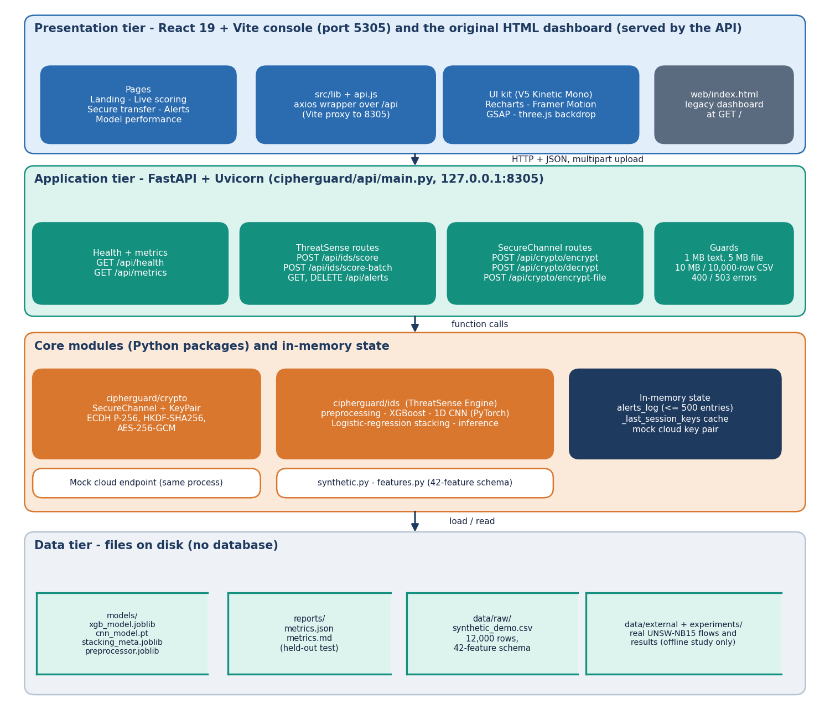
Figure 1: Four-tier architecture of CipherGuard Shield (console, FastAPI application, core packages and in-memory state, file stores).
The presentation tier is a React 19 and Vite console on port 5305, which calls the API through a Vite proxy, together with the original HTML and JavaScript dashboard that the API serves at its root path. The application tier is FastAPI on 127.0.0.1:8305, with route groups for health and metrics, ThreatSense scoring and alerts, and SecureChannel encryption and decryption. Below it sit two Python packages: cipherguard/crypto with SecureChannel and KeyPair, and cipherguard/ids with the preprocessing, training and inference code of the ThreatSense Engine. Three structures live only in process memory: the alert list, the session-key cache and the mock cloud key pair. The data tier consists of files: the model bundle in models/, the metrics report in reports/, the synthetic CSV in data/raw/, and the experiment outputs in experiments/.
The two packages do not import each other. The only place where they meet is main.py, which is a deliberate choice: the console and the tests can exercise each module alone, and the experiments in Chapter 8 time them separately and together.

1.2 High-Level Workflow
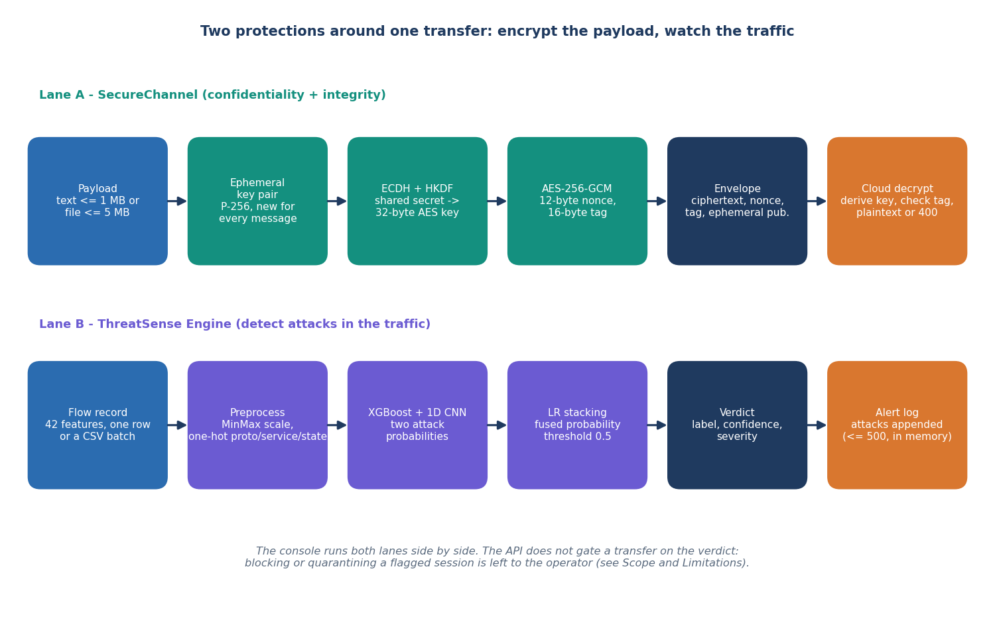
Figure 2: The two protection lanes around one transfer.
Lane A is the confidentiality path. A payload of up to 1 MB of text or 5 MB of file is encrypted with a key that only the sender and the cloud can derive, and the cloud returns the plaintext only if the 16-byte tag verifies. Lane B is the behaviour path. A flow record, or each row of a CSV, is preprocessed, scored by two models and fused into a verdict; attacks are appended to the alert log with a severity.
The two lanes are drawn side by side because that is how the console uses them. A verdict does not hold back or cancel a transfer: the API treats scoring and encryption as independent requests. Coupling a flagged session to a blocked transfer is the first item of future work. What the design does allow is measuring the cost of both lanes for one transfer, which is 5.67 ms for a 100 KB payload in process (Chapter 8).

1.3 Data Flow Diagrams

1.3.1 Level 0
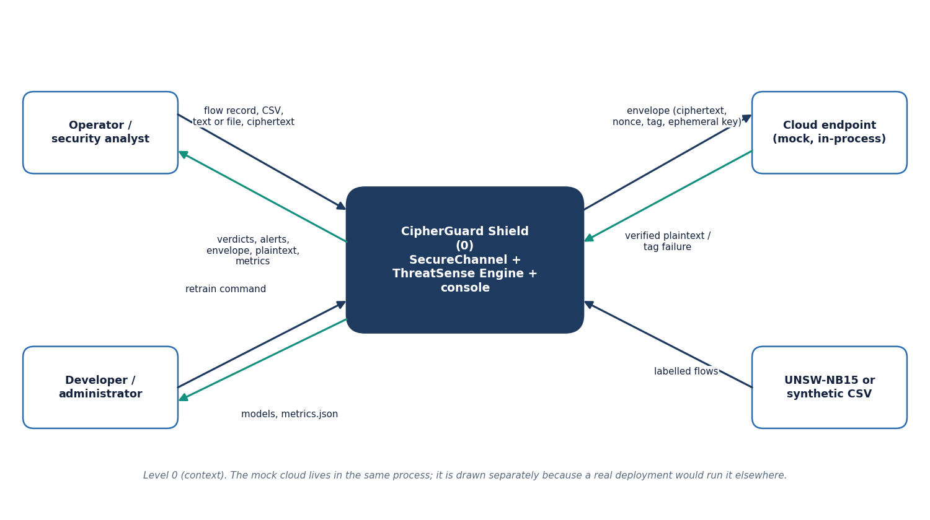
Figure 3: Data flow diagram, level 0 (context).
At the context level CipherGuard Shield is one process with four neighbours. The operator provides flow records, CSV files, text, files and ciphertext and receives verdicts, alerts, envelopes, plaintext and metrics. The developer provides a retrain command and receives models and the metrics file. The cloud endpoint receives envelopes and answers with verified plaintext or a tag failure. The labelled-flow source, UNSW-NB15 or the synthetic CSV, is used only when training.

1.3.2 Level 1
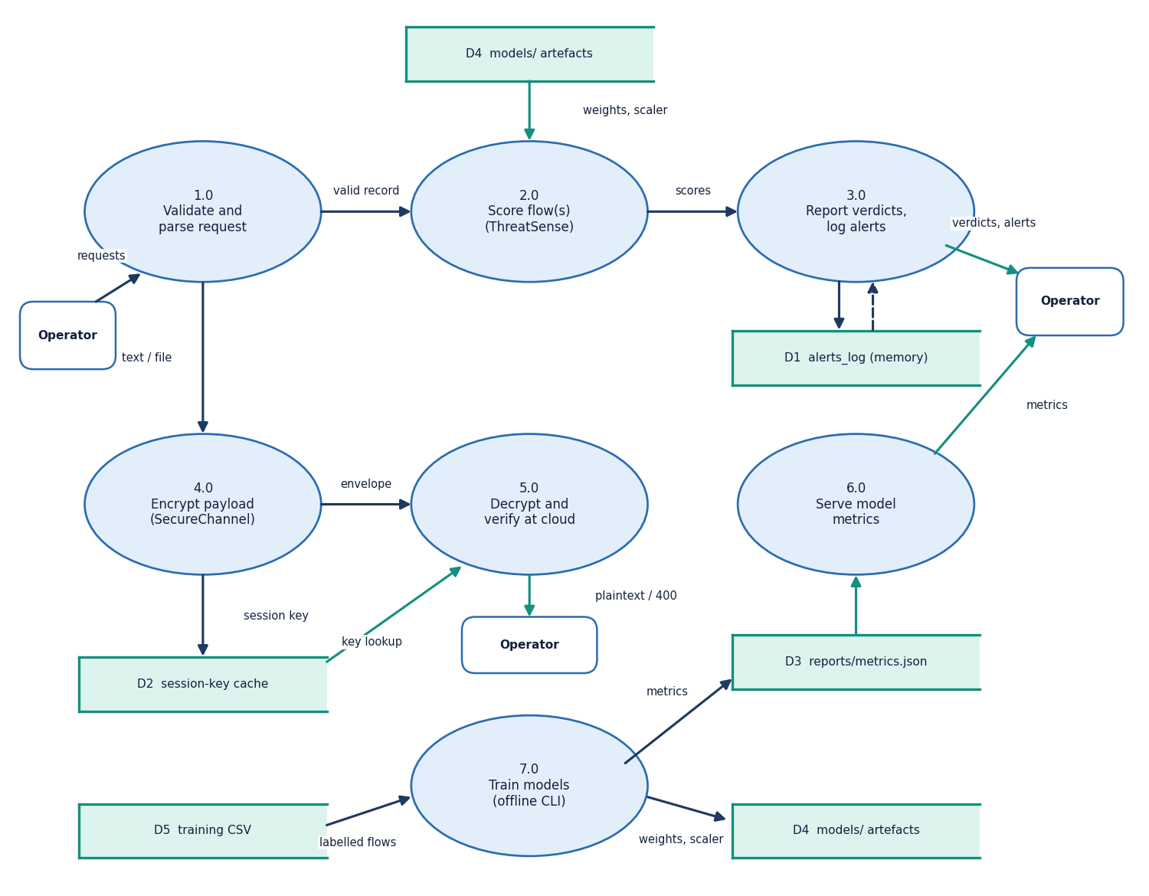
Figure 4: Data flow diagram, level 1.
Level 1 shows seven processes and five stores. Validation (1.0) routes a request either to scoring (2.0) or to encryption (4.0). Scoring reads the stored models (D4) and hands scores to reporting (3.0), which owns the alert log (D1). Encryption writes the session key to the cache (D2); decryption (5.0) reads the cache, falls back to deriving the key with the cloud private key, and answers the operator. The metrics process (6.0) reads metrics.json (D3). Training (7.0) is offline: it reads the training CSV (D5) and writes the models and the metrics file.

1.3.3 Level 2
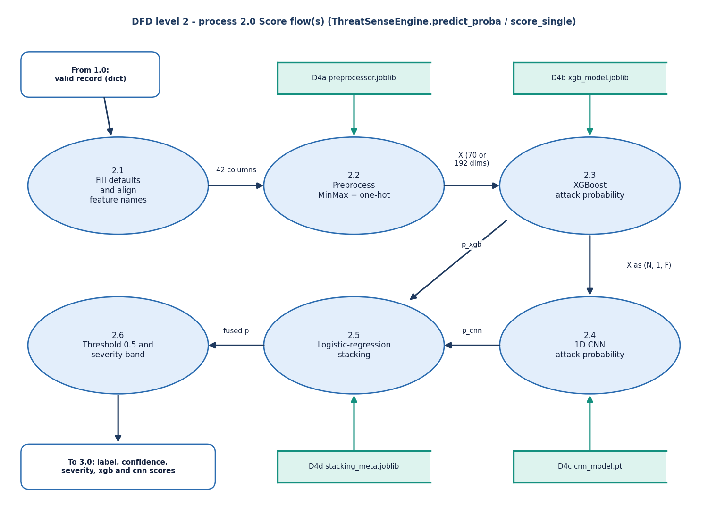
Figure 5: Data flow diagram, level 2, of the scoring process.
The scoring process has six steps. Defaults and name alignment (2.1) make any subset of the 42 features acceptable; the preprocessor (2.2) turns the record into a vector of 70 numbers for the shipped bundle or 192 for the real-data bundle; XGBoost (2.3) and the CNN (2.4) each give an attack probability; the meta-model (2.5) fuses them; and the threshold and severity step (2.6) produces the label returned to the reporting process.

1.4 UML Design

1.4.1 Class Diagram
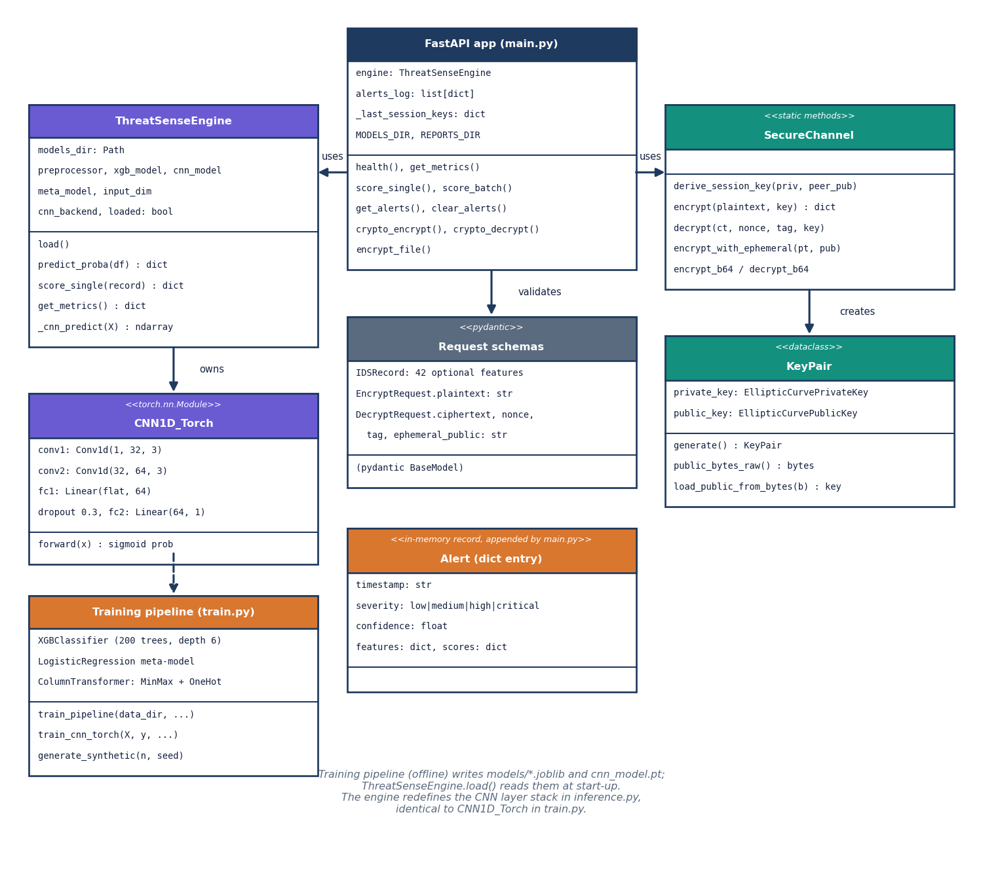
Figure 6: UML class diagram.
The FastAPI application is the only class that knows both modules. It holds a ThreatSenseEngine, the alert list and the session-key cache. ThreatSenseEngine holds the preprocessor, the XGBoost model, the CNN and the meta-model, and its score_single and predict_proba methods are the whole scoring interface. The CNN layer stack is defined twice, in train.py and in inference.py, with identical layers; this duplication keeps inference from importing the training code and its optional TensorFlow probe. SecureChannel is a set of static methods, so a key pair is the only object it creates. The Pydantic schemas validate input, and the alert is a plain dictionary.

1.4.2 Sequence Diagram
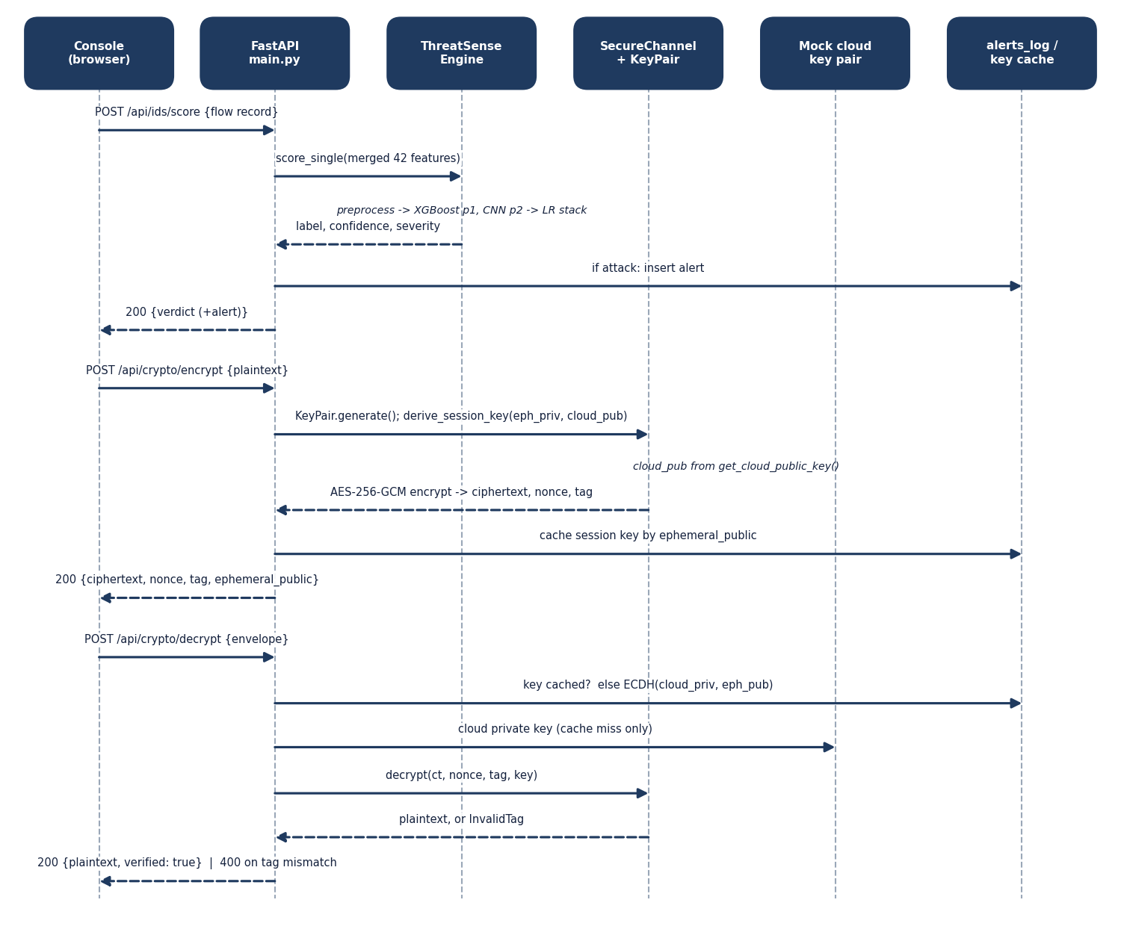
Figure 7: Sequence diagram of scoring, encryption and verified decryption.
The sequence follows three requests. Scoring ends by inserting an alert only for an attack. Encryption derives the key against the cloud public key and caches it under the ephemeral public key, a shortcut that lets the demo decrypt without the cloud's private key. Decryption uses the cache if it can; if the entry is missing, which the test suite forces by clearing the cache, it derives the key with the cloud private key, so the verification does not depend on the shortcut.

1.4.3 Use-Case Diagram
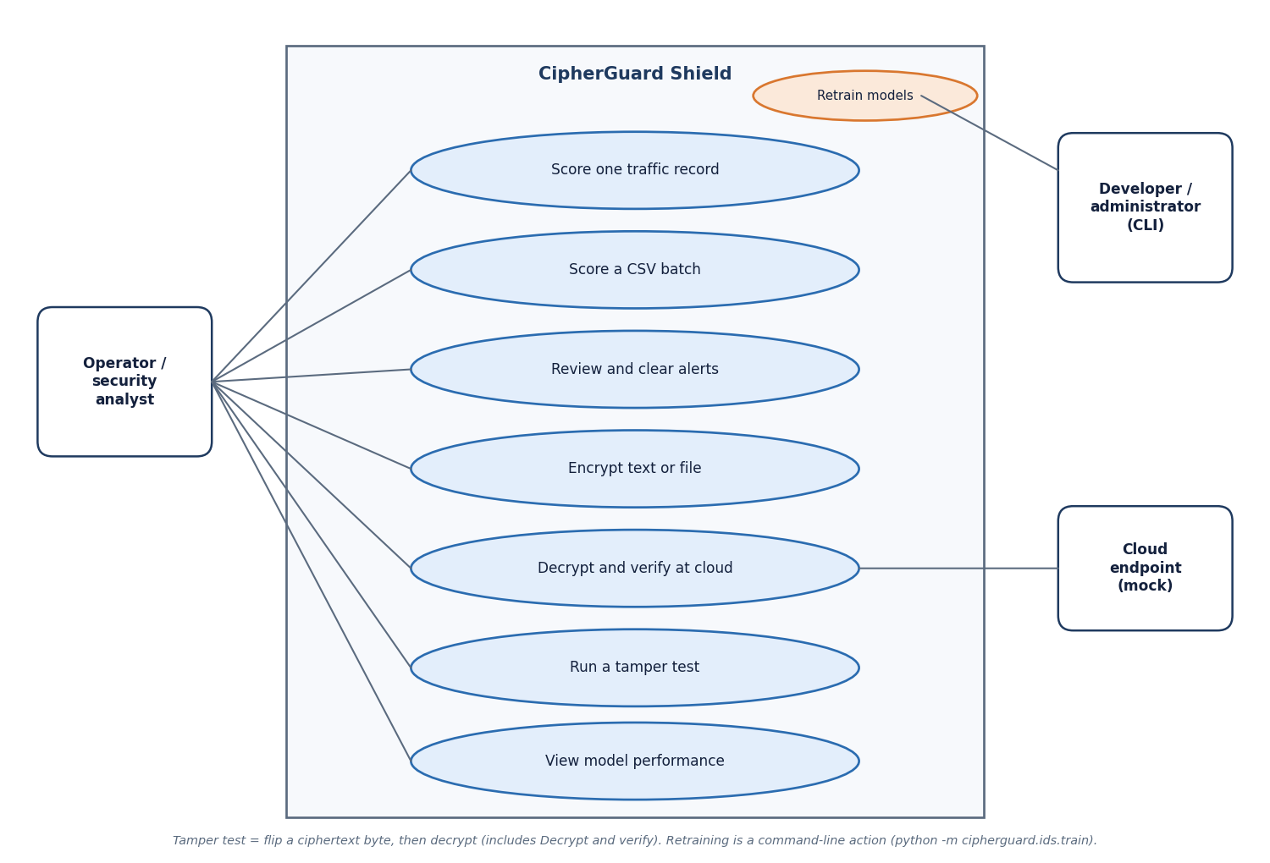
Figure 8: Use-case diagram.
There are seven operator use cases, one of which (decrypt and verify) involves the cloud endpoint, and one developer use case, retraining, which is a command-line action and not a screen of the console.

1.5 Data Design
CipherGuard Shield has no database. This is a design decision, not an omission: the demonstration needs short-lived alerts and per-process keys, and a database would add a dependency without adding a capability the experiments use. The consequence, stated in the limitations, is that alerts and keys are lost on restart. The entity-relationship diagram therefore shows logical entities and their call-time relations.
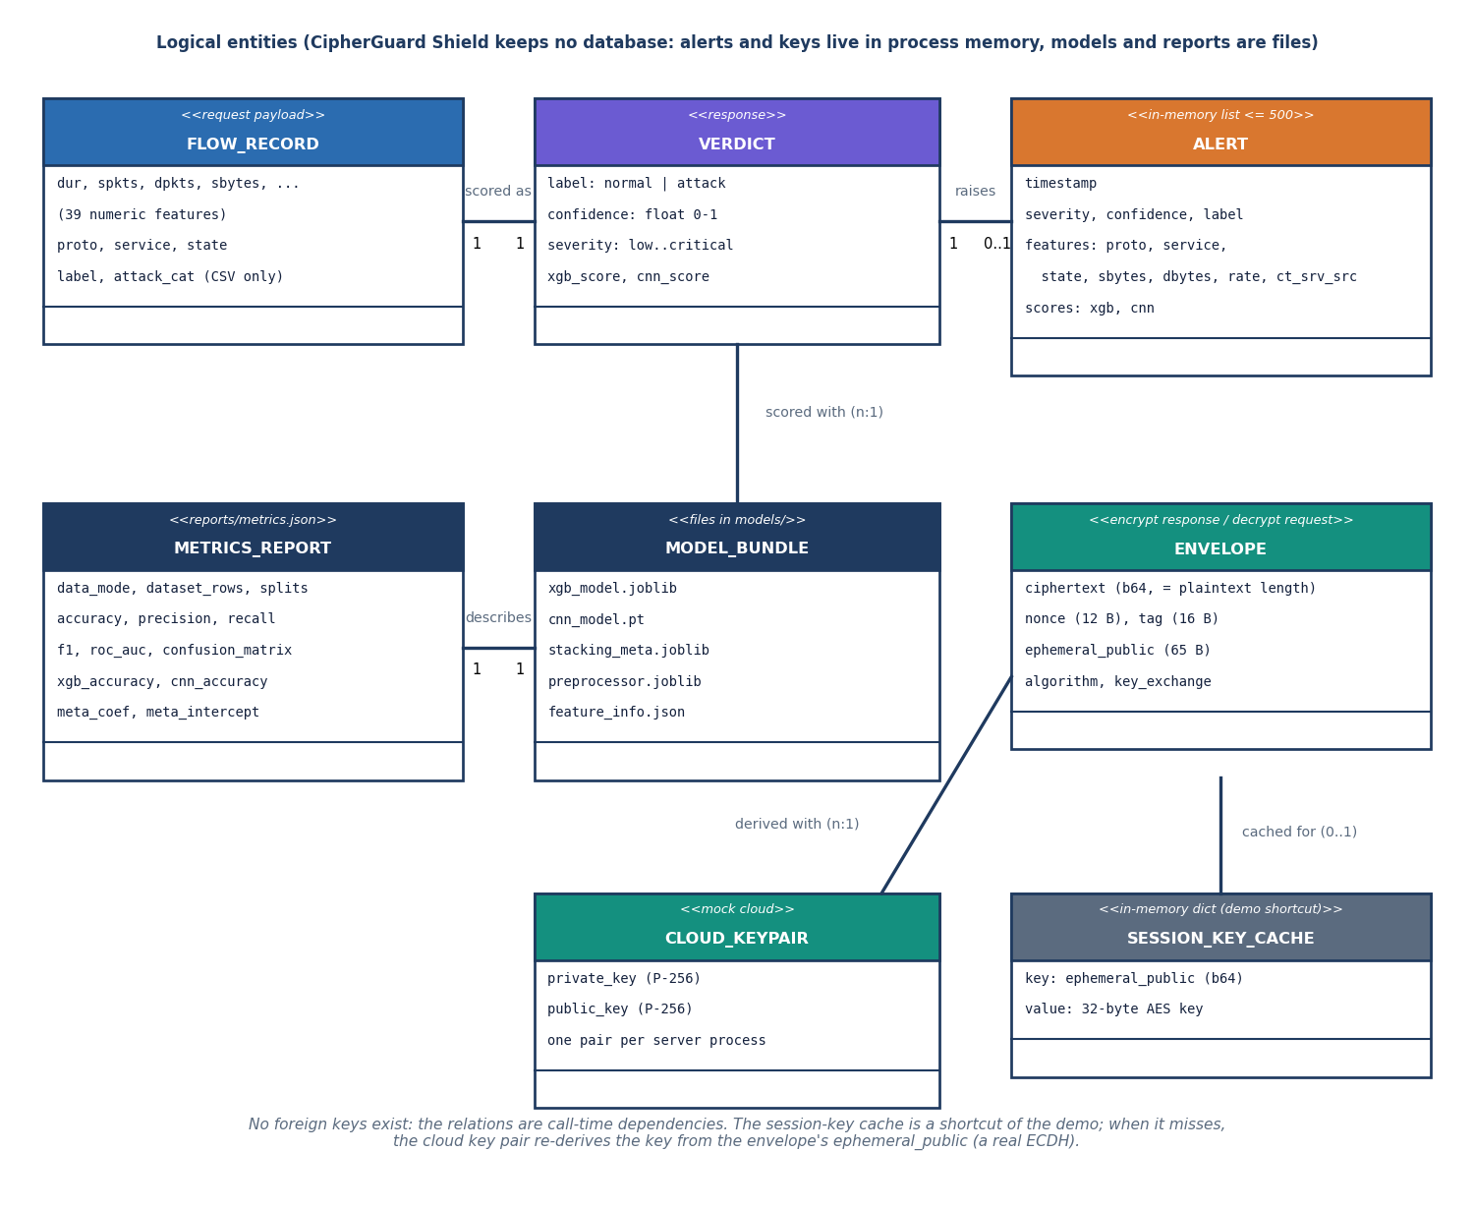
Figure 9: Logical entity-relationship diagram (no database).
Table 2: Data structures and where they live
Structure | Fields | Lives in
Flow record | 42 features: proto, service, state (text) and 39 numeric; optional label, attack_cat in CSV | request body or CSV
Verdict | label, confidence, severity, xgb_score, cnn_score (+ alert for attacks) | response
Alert entry | timestamp, severity, confidence, label, features (proto, service, state, sbytes, dbytes, rate, ct_srv_src), scores (xgb, cnn) | in-memory list, newest first, at most 500
Envelope | ciphertext (base64), nonce (12 B), tag (16 B), ephemeral_public (65 B), algorithm, key_exchange | response and request
Session-key cache | ephemeral public key (base64) to 32-byte AES key | in-memory dict
Cloud key pair | P-256 private and public key, created on first use | in-memory, one per process
Model bundle | xgb_model.joblib, cnn_model.pt, stacking_meta.joblib, preprocessor.joblib, feature_info.json | models/
Metrics report | data mode, split sizes, accuracy, precision, recall, F1, ROC-AUC, confusion matrix, per-model accuracy, meta weights, class balance | reports/metrics.json

The feature schema (cipherguard/ids/features.py) fixes 42 features in a stated order. Three are categorical: proto (six values listed for the synthetic generator), service (thirteen) and state (twelve); the real dataset has more values, which is why its encoded vector has 192 inputs instead of 70. The preprocessor's one-hot encoder is configured to ignore unseen categories, so a value that was not in the training data produces an all-zero block instead of an error.

1.6 Algorithm Design

1.6.1 SecureChannel
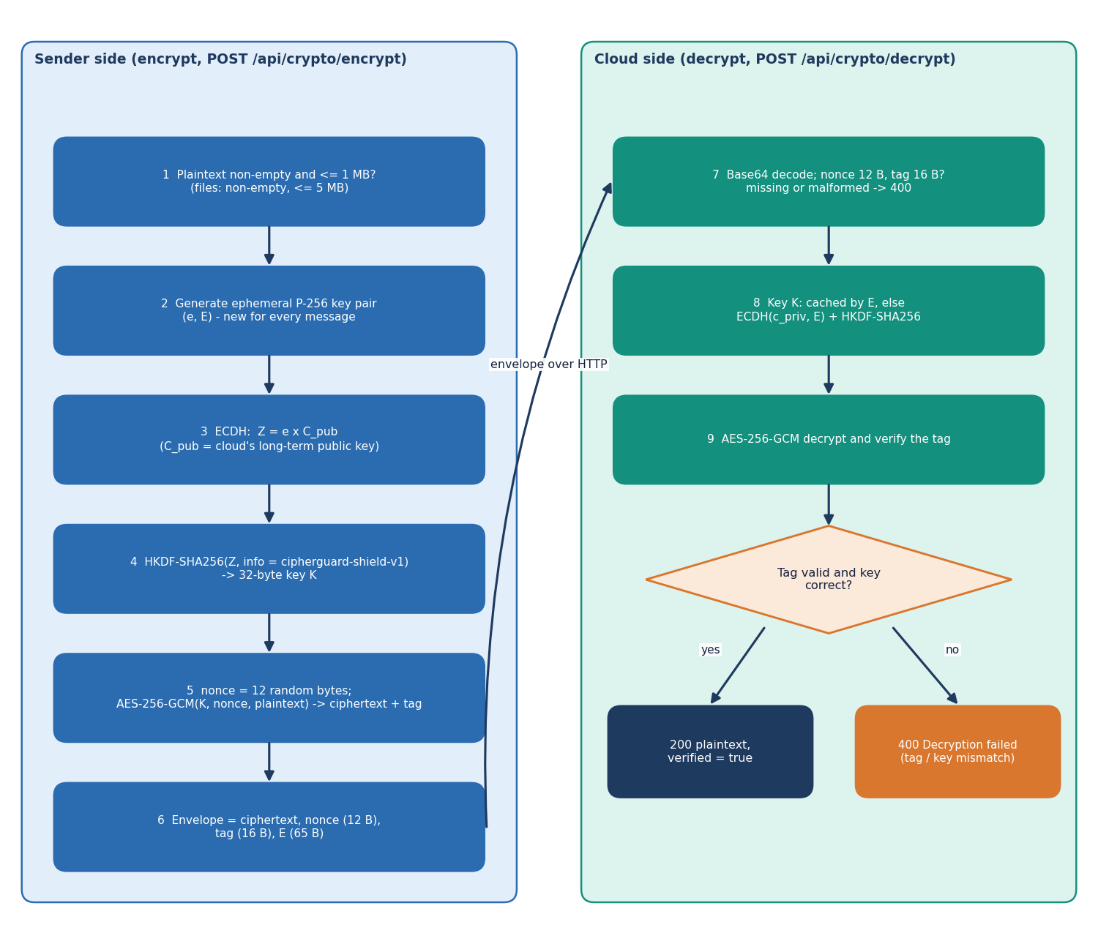
Figure 10: Flowchart of SecureChannel encryption and verified decryption.
The channel follows the standard hybrid pattern: an asymmetric step agrees a key and a symmetric authenticated cipher protects the data. With the cloud's long-term public key Q_c and the sender's fresh private key d_e, the design is:
Z = d_e · Q_c (ECDH on NIST P-256); K = HKDF-SHA256(Z, salt = none, info = "cipherguard-shield-v1", L = 32 bytes) (1)
(C, T) = AES-256-GCM-Enc_K(N, P), N = 96 random bits; P = AES-256-GCM-Dec_K(N, C, T) or reject (2)
The primitives are those specified in NIST SP 800-56A [13], RFC 5869 [14], FIPS 197 [15] and NIST SP 800-38D [12]. The cloud computes the same Z with its private key and the sender's ephemeral public key, so the sender never needs to know a secret that the cloud holds. Because every message also gets a new key, a repeated nonce would not by itself break the scheme, but the implementation still draws a random 96-bit nonce for every message; the benchmark saw 20,000 distinct nonces in 20,000 encryptions. The envelope's fixed overhead is 93 bytes.
The deviation from the batch objective is a design choice recorded here: the key agreement uses elliptic curves instead of RSA. The RSA-OAEP alternative [16] wraps a random AES key with the cloud's RSA public key; its wrapped key is 256 bytes for a 2048-bit modulus against the 65-byte ephemeral point, and the cloud pays an RSA private-key operation per message. The benchmark in Chapter 8 compares the two.

1.6.2 ThreatSense scoring
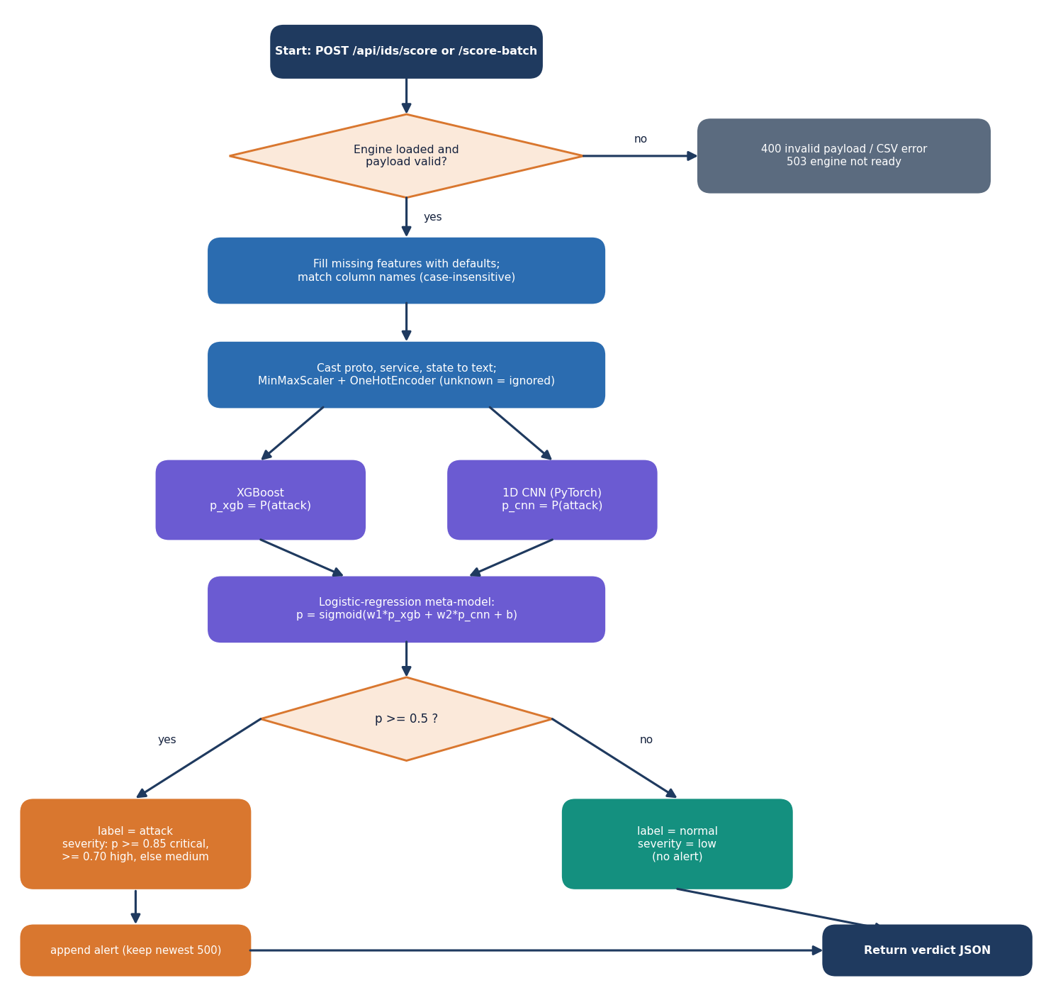
Figure 11: Flowchart of the scoring algorithm.
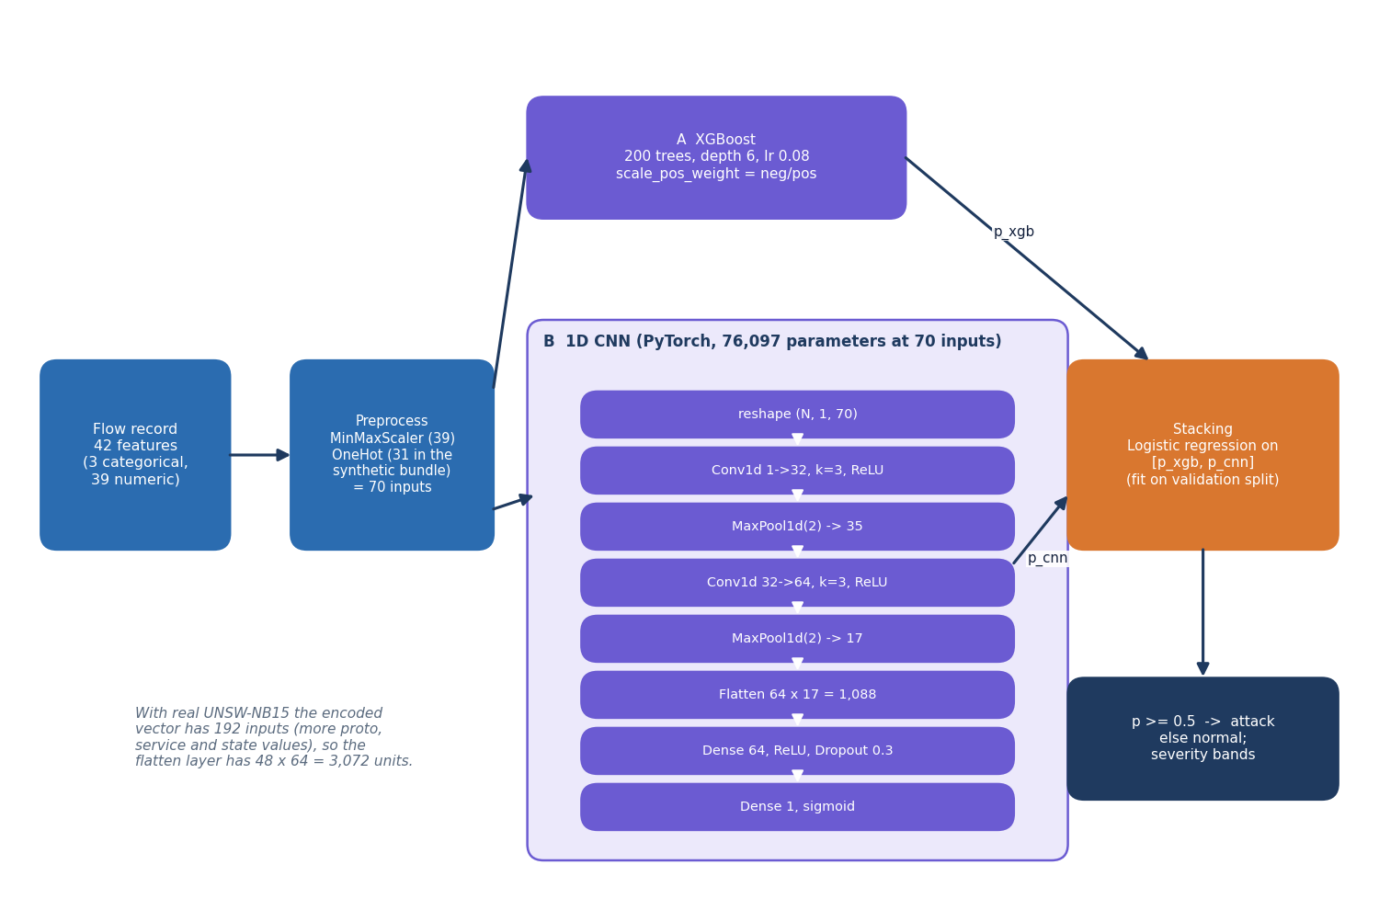
Figure 12: Architecture of the stacked detector.
Preprocessing scales each numeric feature to the range 0 to 1 with min-max normalisation, x' = (x - min) / (max - min), the same first step as the base paper [1], and one-hot encodes the three categorical features. The first model is XGBoost [9] with 200 trees, depth 6, learning rate 0.08, row and column subsampling of 0.85 and scale_pos_weight equal to the ratio of normal to attack rows. The second is a one-dimensional CNN written in PyTorch [18], trained with Adam [19] at 0.001, batch size 256, at most 15 epochs and early stopping with patience 5; it has 76,097 parameters at 70 inputs. Its loss is plain binary cross-entropy: the TensorFlow code path applies balanced class weights, the PyTorch path that actually ran does not.
The two probabilities are fused by stacking [11]: a logistic regression is fitted on the validation split and applied to the test split.
p = σ(w1 · p_xgb + w2 · p_cnn + b); label = attack if p ≥ 0.5, otherwise normal (3)
For the shipped bundle the fitted weights are w1 = 3.77 and w2 = 3.59 with b = -3.57. Severity depends only on p: critical for p ≥ 0.85, high for p ≥ 0.70, medium for any other attack, and low for normal traffic. The base paper fuses its two classifiers with a double-sigmoid median min-max normalisation (DSMMN-SLF); stacking is a simpler analogue, and the documents never call it by that name.

1.7 Module Design
Table 3: Modules, responsibilities and size
Module / file | Responsibility | Lines
cipherguard/crypto/secure_channel.py | KeyPair (P-256 generation, X9.62 encode/decode); SecureChannel: derive_session_key (ECDH + HKDF), encrypt, decrypt (length checks), encrypt_with_ephemeral, base64 helpers; module-level mock cloud key pair | 160
cipherguard/ids/features.py | 42-feature schema, categorical list, label and attack-category column names, allowed category values | 32
cipherguard/ids/preprocessing.py | ColumnTransformer (MinMaxScaler + OneHotEncoder with unknown ignored); tolerant CSV loader; label coercion | 110
cipherguard/ids/synthetic.py | synthetic UNSW-NB15-schema generator with 2.5% label noise | 127
cipherguard/ids/train.py | backend probe, XGBoost, CNN (TensorFlow or PyTorch), stacking, evaluation, artefact and report writing | 462
cipherguard/ids/inference.py | ThreatSenseEngine: load artefacts, prepare features, XGBoost + CNN + meta prediction, severity, metrics read | 186
cipherguard/api/main.py | FastAPI routes, validation, in-memory alert and key caches, static files, model and report directory settings | 382
app.py | entry point; reads BACKEND_PORT from the environment or .env | 23
web/ (legacy dashboard) | HTML, JavaScript and CSS dashboard served by the API | 566
frontend/src/ (React console) | pages, components, hooks and libraries of the console | 3,210
scripts/ and tests/ | capture and smoke scripts, experiments, benchmarks, fetch, serve, bundle builder; 26 tests | see Chapter 7

The modules are small and have one reason to change each. features.py is the single source of the column order that preprocessing.py, train.py, inference.py and main.py all import, so the schema cannot drift between training and serving. main.py is the only module that touches HTTP.

1.8 API Design
Table 4: HTTP interface
Method and path | Request | Response | Errors
GET /api/health | none | status, product, version, engine_loaded | -
GET /api/metrics | none | contents of reports/metrics.json | 404, 503, 500
POST /api/ids/score | JSON object with any subset of the 42 features | label, confidence, severity, xgb_score, cnn_score, alert (attacks) | 400 invalid, 503 / 500 engine
POST /api/ids/score-batch | multipart CSV, at most 10 MB and 10,000 rows | total, attack_count, normal_count, results (first 1,000 rows) | 400 non-CSV / empty / too large, 500, 503
GET /api/alerts?limit= | limit 1 to 500 | alerts (newest first), total | -
DELETE /api/alerts | none | cleared: true | -
POST /api/crypto/encrypt | JSON plaintext, non-empty, at most 1 MB | ciphertext, nonce, tag, ephemeral_public, algorithm, key_exchange, note | 400
POST /api/crypto/decrypt | ciphertext, nonce, tag, ephemeral_public | plaintext, verified | 400 bad base64, missing key, tag or key mismatch
POST /api/crypto/encrypt-file | multipart file, non-empty, at most 5 MB | filename, envelope fields, original_size, encrypted_size | 400
GET /docs, /openapi.json | none | interactive API documentation | -
GET /, /static/* | none | legacy dashboard | 404 for unknown API paths

Validation is strict and returns a meaningful status instead of a stack trace: an empty plaintext, a file of the wrong type, malformed base64 and a mismatched tag all return 400 with a message. A model that is not loaded returns 503. Request bodies are plain JSON; CORS is open to any origin because the server is bound to localhost, a setting that would have to change with any real deployment.
The two directory settings, CIPHERGUARD_MODELS_DIR and CIPHERGUARD_REPORTS_DIR, let the same API serve a different model bundle. They were added during the documentation run so that the bundle trained on real UNSW-NB15 flows could be shown in the console without replacing the shipped files.

1.9 User Interface Design
The console is a React single-page application built on a dark, monospaced design kit with a light theme as an alternative (the choice is remembered in the browser). A sidebar lists the four working screens with keyboard shortcuts, a command palette opened with the slash key jumps to any screen, and an engine badge polls the health route every five seconds. Screenshots of every screen appear in Chapter 8; this section describes their purpose.
Table 5: Console routes
Route | Screen | What the operator does
/ | Landing page | sees live counters and a terminal that calls the real API
/app | Live scoring | fills or presets a flow record, scores it, uploads a CSV, watches the session log and charts
/app/secure | Secure transfer | encrypts text or a file, decrypts and verifies at the cloud, tampers with the ciphertext
/app/alerts | Alerts | filters by severity, refreshes, clears all
/app/performance | Model performance | reads the held-out metrics, confusion matrix and model comparison

• The scoring form exposes three selectors and twelve numeric fields and keeps the remaining 27 features in an advanced section, so that any of the 42 features can be set.
• Presets for a normal flow and an attack flow fill the form and score it, which makes the demonstration repeatable.
• The performance screen states the data mode in a banner, so a reader sees that the shipped numbers come from synthetic data.
• Errors from the API (400, 503, 500) are shown as messages and never as blank screens.

1.10 Key Design Decisions
Table 6: Decisions and their reasons
Decision | Reason | Consequence
ECDH P-256 + HKDF + AES-256-GCM, not RSA + AES | short keys, fresh key per message, one authenticated primitive | differs from objective 1; RSA hybrid benchmarked as baseline
Random 96-bit nonce per message | simple, and safe with a fresh key per message | nonce uniqueness verified over 20,000 messages
Library cryptography only | avoids implementation errors in primitives | security rests on reviewed standards, not on a new scheme
XGBoost + 1D CNN + stacking | strong tabular model, a neural model for diversity, a cheap fusion | stacking did not beat XGBoost alone on real data (Chapter 8)
Schema of 42 UNSW-NB15 features | same features for synthetic and real data | retraining on real data is a file drop
In-memory alerts and keys | no database dependency for a demonstration | state is lost on restart
Mock cloud in the same process | lets the whole channel be tested without infrastructure | no real upload; cloud key not persisted
Scoring independent of transfer | each lane testable alone | no automatic blocking of flagged sessions

1.11 Security and Error-Handling Design
The security design is described against a simple threat model, and the limits of that model are stated. The attacker considered is a party who can read and modify messages between the sender and the cloud endpoint, but who does not hold the cloud's private key. Against that attacker the channel provides confidentiality of the payload and detection of any change to the ciphertext, the nonce, the tag or the key material, because the GCM tag covers them. Replay of an old envelope is not prevented: the service has no message counter or timestamp, so a replayed envelope decrypts again. Traffic analysis is not hidden: message length equals plaintext length.
Table 7: Controls and their limits
Control | What it does | Limit
Authenticated encryption (AES-256-GCM) | rejects modified ciphertext, tag or nonce | no replay protection
Ephemeral ECDH per message | a new key for each message; compromise of one key exposes one message | the cloud's long-term key, if stolen, lets an attacker who recorded envelopes derive their keys, so there is no forward secrecy against that key
Length and type checks | nonce 12 B, tag 16 B, key 32 B; base64 validation | -
Size limits | 1 MB text, 5 MB file, 10 MB CSV, 10,000 rows | no rate limiting
Localhost binding | the server listens on 127.0.0.1 | no authentication or TLS if exposed
No secrets in logs | plaintext and keys are not written to logs | the session-key cache keeps keys in memory

The row on forward secrecy deserves a precise reading. Each message uses a fresh sender key, so the sender's ephemeral secrets are discarded; but the cloud's long-term key pair is the other half of every ECDH exchange, so a party who later obtains it can recompute the session keys of recorded envelopes. The design therefore gives per-message key independence, not full forward secrecy; achieving the latter would need an interactive handshake with ephemeral keys on both sides, which is future work.
Errors follow one rule: a failure is reported with a status code and a short message, and the server keeps running. The decrypt route returns the same 400 status for a wrong tag and a wrong key, and its message names both causes, so a client cannot tell which one failed.

2. IMPLEMENTATION

2.1 Application architecture
CipherGuard Shield is a single Python process behind a web interface. The browser tier is a React 19 console built with Vite and Tailwind (screens: landing page, live scoring, secure transfer, alerts, model performance) that calls the API through axios and a Vite proxy; the original plain HTML and JavaScript dashboard in web/ is still served by the API at /. The application tier is a FastAPI application (cipherguard/api/main.py, 382 lines) served by Uvicorn on 127.0.0.1:8305. It delegates to two packages: cipherguard/crypto with the SecureChannel and KeyPair classes, and cipherguard/ids with the preprocessing, the training code and the ThreatSenseEngine that loads the model files and scores records.
Figure 13: Layered architecture of CipherGuard Shield.
Table 8: Modules and their responsibilities.
Module | Responsibility
cipherguard/crypto/secure_channel.py | KeyPair (P-256 generation, X9.62 uncompressed encoding and decoding); SecureChannel (ECDH + HKDF key derivation, AES-256-GCM encrypt and decrypt, one-shot ephemeral encryption)
cipherguard/ids/features.py | The 42-feature schema, categorical feature names, and the allowed category values used by the generator
cipherguard/ids/preprocessing.py | ColumnTransformer with MinMax and one-hot branches; tolerant CSV loading; helper that fills missing columns
cipherguard/ids/synthetic.py | Seeded generator of the synthetic demonstration dataset
cipherguard/ids/train.py | Training pipeline: XGBoost, PyTorch (or TensorFlow) CNN, stacking meta-model; writes models/ and reports/
cipherguard/ids/inference.py | ThreatSenseEngine: loads the artefacts, predicts probabilities, derives label and severity
cipherguard/api/main.py | FastAPI routes, validation, in-memory alert log, session-key cache, mock cloud key pair, static file serving
web/ and frontend/ | Legacy dashboard (HTML, CSS, JS) and the React console
scripts/ | smoke_test, capture_screens, run_experiments, benchmark_crypto, measure_pipeline, make_real_bundle, fetch_unsw_nb15, serve
tests/ | 26 pytest tests for the crypto, the engine and the API

State is kept in three places and nowhere else. The model files in models/ and the report in reports/ are read at start-up. The alert log is a Python list of at most 500 entries, newest first, lost when the process stops. The cloud's key pair is generated on first use and lives for the lifetime of the process, as does a dictionary that caches session keys by ephemeral public key; this is a shortcut of the demonstration, and when the cache misses (for example for an envelope created before a restart of the cache) the API re-derives the key from the cloud private key and the envelope's ephemeral public key, which is the real protocol. There is no database.

2.2 API design
The API is JSON over HTTP, plus two multipart upload routes. Table 6.3 lists every route; the interactive Swagger page at /docs documents the same contract.
Table 9: API routes of CipherGuard Shield.
Method and path | Request | Success response | Errors
GET /api/health | - | status, product, version, engine_loaded | -
GET /api/metrics | - | contents of reports/metrics.json | 404 not found, 503 engine
POST /api/ids/score | JSON object with any subset of the 42 features | label, confidence, severity, xgb_score, cnn_score, alert (attacks only) | 400 invalid record, 503 / 500 engine
POST /api/ids/score-batch | multipart CSV, at most 10 MB and 10,000 rows | total, attack_count, normal_count, results (first 1,000 rows) | 400 not CSV / empty / too large / unparsable
GET /api/alerts?limit= | limit 1 to 500 (default 100) | alerts (newest first), total | -
DELETE /api/alerts | - | cleared: true | -
POST /api/crypto/encrypt | plaintext (1 byte to 1 MB) | ciphertext, nonce, tag, ephemeral_public (all base64), algorithm, key_exchange | 400 empty or too large
POST /api/crypto/decrypt | ciphertext, nonce, tag, ephemeral_public | plaintext, verified: true | 400 bad base64, missing key, tag or key mismatch
POST /api/crypto/encrypt-file | multipart file, 1 byte to 5 MB | filename, envelope fields, original_size, encrypted_size | 400 missing, empty or too large

The score route accepts any subset of the 42 features. The server fills the rest with defaults defined in the IDSRecord model, overlays the supplied values, and passes the 42-field record to the engine; if the verdict is attack the route builds an alert entry (timestamp, severity, confidence, the protocol, service, state, source and destination bytes, rate and ct_srv_src, and the two model scores), inserts it at the head of the list and returns it with the verdict. The batch route scores a CSV in one vectorised call and adds one alert per attack row.
The encrypt route performs the sender's side and the cloud's long-term public key is the only key it needs; it returns the envelope as base64 strings so that it can be pasted into a text field. The decrypt route is the cloud's side: it decodes the envelope, obtains the AES key, and returns the plaintext only if the tag verifies. The envelope fields are independent, so the console can alter the ciphertext between the two calls and demonstrate the rejection.
Figure 14: Sequence of a scoring request, an encryption request and a decryption request through the API.

2.3 Security and error handling

2.3.1 What the design protects
• Confidentiality. Each message is encrypted under its own 256-bit key. Nonces come from the operating system's random source (os.urandom); in 20,000 encryptions the benchmark observed 20,000 distinct nonces and 20,000 distinct ciphertexts for one repeated plaintext.
• Integrity and authenticity of the ciphertext. GCM's tag covers the ciphertext; flipping a single bit of the ciphertext, the tag or the nonce, truncating the ciphertext, or decrypting with another party's key was rejected in every one of 1,000 trials per case.
• Fresh key per message. The sender code creates a new ephemeral key pair for every message and does not store its private part, so the keys of different messages are independent. The demonstration API does keep each derived session key in an in-memory cache (see below), which weakens this property for the lifetime of the process.
• Input limits. Plaintext 1 MB, files 5 MB, CSV 10 MB and 10,000 rows, empty inputs refused, a CSV extension required; malformed base64 and wrong-length fields produce HTTP 400 with a message, never a stack trace.

2.3.2 What it does not protect
• The cloud is a mock. The key pair is created inside the same process and is never written to disk, so there is no key storage, rotation or revocation, and the session-key cache holds every session key in memory for the lifetime of the process.
• No authentication or authorisation. Any client that can reach the port can encrypt, decrypt and clear alerts. CORS is set to *. The server binds to 127.0.0.1 by default, which is the only access control.
• No transport security. The service speaks plain HTTP on the loopback interface; a real deployment needs TLS, and the ECDH step does not authenticate the sender (an active attacker could substitute its own ephemeral key).
• Detection is advisory. The verdict does not block a transfer; the console runs the two lanes side by side and the operator decides.
• The detector can be evaded. No adversarial testing was done, and the model's strongest feature on real data (sttl) is an attribute of the testbed that an attacker can set freely.
Table 10: Error handling in the API.
Situation | Response | Where
Model files missing at start-up | Training is started automatically; if loading still fails, routes return 503 | startup_event, ensure_engine
Empty or non-JSON record, invalid field type | 400 "Invalid record" | score route
Upload is not a .csv file, is empty, unparsable, > 10 MB or > 10,000 rows | 400 with the reason | score-batch route
Empty plaintext, plaintext > 1 MB, file empty or > 5 MB | 400 with the reason | encrypt routes
Invalid base64, missing ephemeral key, malformed point | 400 "Invalid base64 encoding" or "Invalid ephemeral_public" | decrypt route
Tag mismatch or wrong key | 400 "Decryption failed (tag verification or key mismatch)" | decrypt route
Unexpected exception in scoring | 500 with the exception text | score and batch routes

2.4 Installation and execution
The product is run in one of three ways; the complete step-by-step guide is Appendix B and HOW_TO_RUN.md.
1. run.bat (Windows). Creates a virtual environment, installs requirements.txt (FastAPI, Uvicorn, cryptography, XGBoost, scikit-learn, PyTorch, pandas), trains the models if models/ is empty, installs the React dependencies with npm install, starts the API on 8305 and the console on 5305 and opens the browser.
2. Manual. pip install -r requirements.txt, then python -m uvicorn cipherguard.api.main:app --host 127.0.0.1 --port 8305, and in frontend/ npm install and npm run dev.
3. Docker. run-docker.bat builds the image from the Dockerfile and maps container port 8000; this path was not exercised in the documentation run.
Loading the shipped models takes about 112 ms on the measurement machine, so the API is ready a second or two after start-up. Ports and host come from .env (BACKEND_PORT, FRONTEND_PORT).
Three additions of the documentation run are part of the execution story. python scripts/fetch_unsw_nb15.py downloads the official training and testing files (about 19 MB) into data/external/ (ignored by git). python scripts/run_experiments.py [official] [paper] [shift] reproduces the experiments (about 25 minutes on the measurement machine). python scripts/make_real_bundle.py turns the seed-42 models into a bundle the API can serve; the bundle is selected with two environment variables:
set CIPHERGUARD_MODELS_DIR=experiments\unsw_nb15\official\models
set CIPHERGUARD_REPORTS_DIR=experiments\unsw_nb15\official\reports
python scripts\serve.py

With these variables unset, the API serves the shipped synthetic-trained bundle. scripts/serve.py imports PyTorch before anything else: on the Windows machine used here, PyTorch's DLLs fail to initialise (error 1114) when NumPy or pandas have already been imported, so the launcher and the test configuration (tests/conftest.py) import it first. The run.bat environment, which pins PyTorch 2.2.0, was not re-run.
Verification after installation is python -m pytest tests (26 tests) and python scripts/smoke_test.py (15 checks against the running API; --frontend repeats them through the Vite proxy), described in Chapter 7. python scripts/capture_screens.py and capture_real_screens.py regenerate the screenshots used in Chapters 7 and 8.

3. KEY CODE WALK-THROUGHS
This section walks through the code that carries the design. The listings are copied from the repository at the state in which the results were measured.

3.1 Key derivation
def _derive_aes_key(shared_secret: bytes, info: bytes = b"cipherguard-shield-v1") -> bytes:
"""HKDF-SHA256: derive 32-byte AES-256 key."""
hkdf = HKDF(
algorithm=hashes.SHA256(),
length=32,
salt=None,
info=info,
)
return hkdf.derive(shared_secret)

@staticmethod
def derive_session_key(
private_key: ec.EllipticCurvePrivateKey,
peer_public_key: ec.EllipticCurvePublicKey,
info: bytes = b"cipherguard-shield-v1"
) -> bytes:
shared = private_key.exchange(ec.ECDH(), peer_public_key)
return _derive_aes_key(shared, info=info)

derive_session_key performs the elliptic-curve Diffie-Hellman exchange on P-256 and passes the shared secret through HKDF with SHA-256, no salt and the context string cipherguard-shield-v1, giving a 32-byte AES-256 key. Both sides compute the same key because ECDH is symmetric: the sender uses its ephemeral private key and the cloud's public key, the cloud uses its private key and the sender's ephemeral public key. The raw shared secret is never used as a key, which is the reason for HKDF [14]. The same function serves both directions, which keeps the encrypt and decrypt paths short and testable.

3.2 Authenticated encryption
@staticmethod
def encrypt(plaintext: bytes, session_key: bytes) -> dict:
"""
AES-256-GCM encrypt.
Returns dict with base64-encoded ciphertext, nonce, tag is inside ciphertext.
We split for UI clarity: AESGCM returns ciphertext+tag combined; we separate last 16 bytes as tag.
"""
if len(session_key) != 32:
raise ValueError("session_key must be 32 bytes for AES-256")
nonce = os.urandom(12) # 96-bit nonce per NIST
aesgcm = AESGCM(session_key)
ct_with_tag = aesgcm.encrypt(nonce, plaintext, None)
# AESGCM appends 16-byte tag
ciphertext = ct_with_tag[:-16]
tag = ct_with_tag[-16:]
return {
"ciphertext": base64.b64encode(ciphertext).decode(),
"nonce": base64.b64encode(nonce).decode(),
"tag": base64.b64encode(tag).decode(),
"ciphertext_raw": ciphertext,
"nonce_raw": nonce,
"tag_raw": tag,
}

AESGCM.encrypt returns the ciphertext with the 16-byte tag appended; the code splits them so that the interface can show the nonce, the ciphertext and the tag separately. The nonce is 12 random bytes from the operating system for every message, the size recommended for GCM [12], and because the key itself is fresh for every message a nonce repeat is not a realistic risk (20,000 trials produced 20,000 distinct nonces). Decryption re-joins ciphertext and tag and AESGCM.decrypt raises InvalidTag on any modification, which is what produces the 400 response.

3.3 One-shot encryption to the cloud
@staticmethod
def encrypt_with_ephemeral(plaintext: bytes, recipient_public_key: ec.EllipticCurvePublicKey) -> dict:
"""
One-shot: generate ephemeral keypair, ECDH, encrypt. Returns ephemeral public + encrypted payload.
Useful for 'transmission to cloud' demo where cloud has long-term key.
"""
ephemeral = KeyPair.generate()
session_key = SecureChannel.derive_session_key(ephemeral.private_key, recipient_public_key)
enc = SecureChannel.encrypt(plaintext, session_key)
return {
"ephemeral_public": base64.b64encode(ephemeral.public_bytes_raw()).decode(),
"ciphertext": enc["ciphertext"],
"nonce": enc["nonce"],
"tag": enc["tag"],
"_ephemeral_private": ephemeral.private_key, # internal, not serialized
"_session_key": session_key,
}

encrypt_with_ephemeral generates a new P-256 key pair, derives the key against the recipient's public key and returns the envelope fields, including the 65-byte uncompressed ephemeral public key. It also returns the ephemeral private key and the session key under underscore-prefixed names for in-process use; the API does not serialise them. The benchmark in Chapter 8 times exactly this function, which is why its figures include the key generation and the base64 conversion.

3.4 Decryption at the cloud with a fall-back
# Derive session key: prefer stored ephemeral key, otherwise try ECDH with cloud private
session_key = None
if req.ephemeral_public and req.ephemeral_public in _last_session_keys:
session_key = _last_session_keys[req.ephemeral_public]
elif req.ephemeral_public:
# Derive via cloud private key + ephemeral public (real ECDH)
try:
eph_pub_bytes = base64.b64decode(req.ephemeral_public)
eph_pub = KeyPair.load_public_from_bytes(eph_pub_bytes)
cloud_priv = get_cloud_keypair().private_key
session_key = SecureChannel.derive_session_key(cloud_priv, eph_pub)
except Exception as e:
raise HTTPException(status_code=400, detail=f"Invalid ephemeral_public: {e}")
else:
raise HTTPException(status_code=400, detail="ephemeral_public required for decryption (ECDH)")

try:
pt = SecureChannel.decrypt(ct, nonce, tag, session_key)
return {"plaintext": pt.decode(errors="replace"), "verified": True}
except Exception as e:
# AESGCM tag mismatch etc.
raise HTTPException(status_code=400, detail=f"Decryption failed (tag verification or key mismatch): {e}")

The decrypt route first looks for a cached key, a demo shortcut kept so that the console can decrypt without holding the cloud's private key; if the cache has no entry it performs the real exchange with the cloud key pair. Malformed base64 and an unparsable ephemeral key give 400 with a message; a tag or key mismatch also gives 400 and releases no plaintext. A test clears the cache and checks that decryption still works.

3.5 Scoring a record
def predict_proba(self, df: pd.DataFrame) -> dict:
self.ensure_loaded()
X = self._prepare_X(df)
xgb_proba = self.xgb_model.predict_proba(X)[:, 1]
cnn_proba = self._cnn_predict(X)
stack_X = np.column_stack([xgb_proba, cnn_proba])
ensemble_proba = self.meta_model.predict_proba(stack_X)[:, 1]
preds = (ensemble_proba >= 0.5).astype(int)
return {
"ensemble_proba": ensemble_proba.tolist(),
"ensemble_pred": preds.tolist(),
"xgb_proba": xgb_proba.tolist(),
"cnn_proba": cnn_proba.tolist(),
"labels": ["attack" if p == 1 else "normal" for p in preds],
}

predict_proba transforms the frame with the stored preprocessor (min-max scaling of 39 numeric features and one-hot encoding of protocol, service and state, ignoring unseen categories), gets the XGBoost probability and the CNN probability, stacks them as two columns and lets the logistic-regression meta-model produce the final probability. The label is attack when that probability is at least 0.5. score_single adds the severity bands of 0.70 (high) and 0.85 (critical). The CNN input is reshaped to (rows, 1, features), the 1D-sequence view of the flow vector used by the shipped architecture.

3.6 Training the stack
# ---- Fusion: Logistic Regression stacking (ensemble stacking) ----
print("[ThreatSense] Training stacking meta-model (Logistic Regression)...")
stack_X_val = np.column_stack([xgb_val_proba, cnn_val_proba])
meta = LogisticRegression()
meta.fit(stack_X_val, y_val)

The meta-model is trained on the validation split's probabilities, not on the training split's, so that it sees predictions of models that did not fit those rows. That is the textbook way to stack [11], but it also explains a result of Chapter 8: when the test period differs from the validation period, the meta-model's weights, which favour the CNN's confident outputs, no longer fit.

4. IMPLEMENTATION DECISIONS AND THEIR REASONS
Each design decision below was taken for a reason and has a cost; the table states both.
Table 11: Implementation decisions and their reasons
Decision | Chosen | Alternative | Reason and consequence
Key agreement | ECDH P-256 with an ephemeral key per message | RSA-OAEP key wrapping; static key pair | Smaller keys (65 B against 256 B wrapped), cheaper unwrap at the cloud (0.10 ms against 0.45 ms), forward secrecy per message. RSA-2048 and 3072 were kept as measured baselines.
Key derivation | HKDF-SHA256 with a context string | Using the ECDH output directly as a key | The raw shared secret is not uniformly random; HKDF is the standard remedy.
Payload cipher | AES-256-GCM | AES-CBC with HMAC; ChaCha20-Poly1305 | Authenticated encryption in one primitive; hardware-accelerated; maintained implementation. No custom cryptography.
Nonce | 12 random bytes per message | Counter | Fresh key per message makes random nonces safe and stateless.
Detector | XGBoost + 1D CNN + logistic-regression stack | Single model; deep fusion as in the base paper | Cheap on a CPU, transparent, and a direct analogue of score-level fusion. Chapter 8 shows XGBoost alone is at least as good.
CNN framework | PyTorch (TensorFlow code path kept) | TensorFlow only | TensorFlow failed to load on the development host; the PyTorch path has the same layer stack.
Training data default | Synthetic generator in the same 42-feature schema | Bundling the real dataset | Runs out of the box with no download or licence step; the cost is the synthetic-data trap documented in Chapter 8. Real data are one script away.
Alert store | In-memory list capped at 500 | Database | Smallest thing that works for a demonstration; the cost is loss on restart.
Cloud | Mock endpoint with a process key pair | Real provider | Lets the whole path be tested offline; key custody is therefore not demonstrated.
Interfaces | REST API, React console, legacy HTML page | Console only | The legacy page needs no build step and remains a fall-back.
Model switching | CIPHERGUARD_MODELS_DIR / CIPHERGUARD_REPORTS_DIR | Overwriting models/ | Lets a real-trained bundle be served without touching the shipped one.

Two decisions were forced by the environment rather than chosen. On the measurement host import torch fails if numpy or pandas are imported first, so the experiment scripts, the test suite and scripts/serve.py import torch first; the shipped run.bat creates its own virtual environment and was not re-run here. The experiments also run on a shared CPU, which is why absolute timings are reported as indicative.

